FEDERAL POLYTECHNIC NEKEDE, OWERRI.
P.O BOX 1036
IMO STATE.

COMPILER CONSTRUCTION
PRACTICAL on COM 414

Name: UMEH CATHERINE CHISOM
Reg No: 17EH/0057/CS
Department: COMPUTER SCIENCE
Programme: EVENING
Level: HND 2
Date: June, 2019.
TASK I: COMPILE THE ABOVE PROGRAM AND OBSERVE THE COMPILATION PROCESS.
SOURCE CODE
public class resultsheets {
public static void main(String[]args){
System.out.println("JAMB RESULT");
String studfirstname = "Adaora";
String studlastname = "Obi";
int English=50;
int maths =60;
int bio = 70;
int chem = 40;
int average, total;
String Grade, Remark;
total=(English+maths+bio+chem);
average=total/4;
System.out.println(studfirstname+" "+studlastname);
System.out.println("...................");
System.out.println("English language = "+English);
System.out.println("Mathematics = "+maths);
System.out.println("Biology = "+bio);
System.out.println("Chemistry = "+chem);
System.out.println("Total Score is"+" "+total);
System.out.println("Average Score is"+" "+average);
if(average<=39){
Grade = "F" ;
Remark = "Fail";
}else if(average<=44 && average>=40){
Grade = "E";
Remark = "Very poor";
}else if(average<=49 && average>=45){
Grade = "D";
Remark = "Poor";
}else if(average<=59 && average>=50){
Grade = "C";
Remark = "Good";
}else if(average<=69 && average>=60){
Grade = "B";
Remark = "Very Good";
}else{
Grade = "A";
Remark = "Excellent";
}
System.out.println("Grade"+" "+Grade);
System.out.println("Remark="+" "+Remark);
}
}
TASK II: RE-WRITE THE ABOVE PROGRAM USING C++, COMPILE AND EXECUTE.

SOURCE CODE
#include <iostream>
using namespace std;
int main()
{
string studfirstname;
string studlastname, Grade, Remark;
int English, maths, bio, chem, average, total;
English = 50;
maths = 60;
bio = 70;
chem = 40;
studfirstname = "Adaora";
studlastname = "Obi";
cout<<"JAMB RESULT"<<endl;
total = (English+maths+bio+chem);
average = total/4;
cout<<studfirstname<<" "<<studlastname<<endl;
cout<<".................."<<endl;
cout<<"English Language "<<English<<endl;
cout<<"Mathematics "<<maths<<endl;
cout<<"Biology "<<bio<<endl;
cout<<"Chemistry "<<chem<<endl;
cout<<"Total Score is "<<total<<endl;
cout<<"Average Score is "<<average<<endl;
if(average<=39){
Grade = "F";
Remark = "Fail";
}else if(average<=44 && average>=40){
Grade = "E";
Remark = "Very poor";
}else if(average<=49 && average>=45){
Grade = "D";
Remark = "Poor";
}else if(average<=59 && average>=50){
Grade = "C";
Remark = "Good";
}else if(average<=69 && average>=60){
Grade = "B";
Remark = "Very Good";
}else{
Grade = "A";
Remark = "Excellent";
}
cout<<"Grade = "<<Grade<<endl;
cout<<"Remark = "<<Remark<<endl;
return 0;
}
TASK III: RE-WRITE THE PROGRAM USING QBASIC, RUN THE PROGRAM AND OBSERVE THE INTERPRETATION PROCESS.

SOURCE CODE
DIM studfirstname as string = "Adaora"
DIM studlastname as string = "Obi"
DIM English as integer = 50
DIM maths as integer = 60
DIM bio as integer = 70
DIM chem as integer = 40
DIM Grade as string
DIM Remark as string
DIM total as integer
DIM average as integer
total = English+maths+bio+chem
average = total/4
print "JAMB RESULT"
print studfirstname; " "; studlastname
print "........................."
print "English Language = "; English
print "Mathematics = "; maths
print "Biology = "; bio
print "Chemistry = "; chem
print "Total Score is "; total
print "Average Score is "; average
if average<=39 then
Grade = "F"
Remark = "Fail"
elseif average<=44 and average>=40 then
Grade = "E"
Remark = "Very poor"
elseif average<=49 and average>=45 then
Grade = "D"
Remark = "Poor"
elseif average<59 and average>=50 then
Grade = "C"
Remark = "Good"
elseif average<=69 and average>=60 then
Grade = "B"
Remark = "Very Good"
else
Grade = "A"
Remark = "Excellent"
end if
print "Grade = "; Grade
print "Remark = "; Remark

OUTPUT
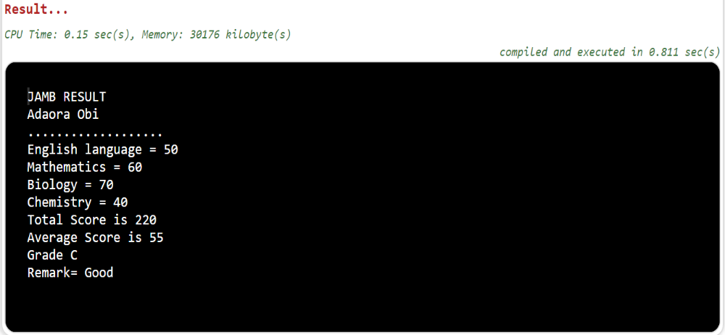

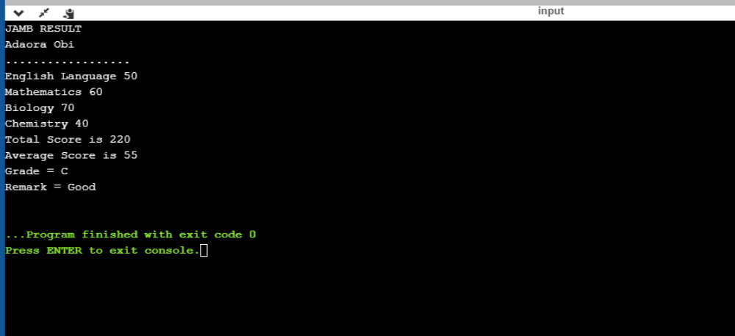
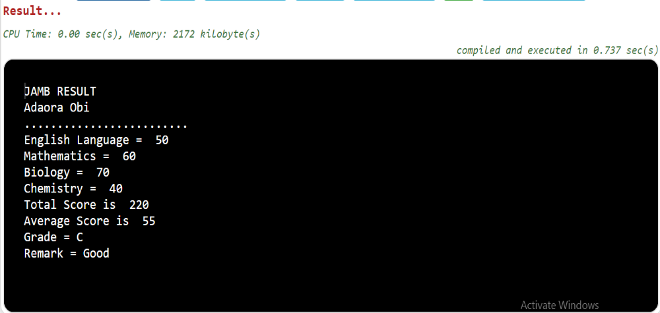

FEDERAL POLYTECHNIC NEKEDE, OWERRI.
P.O BOX 1036
IMO STATE.

COMPILER CONSTRUCTION
PRACTICAL on COM 414

Name: TAIWO AFOLASHADE ALICE
Department: COMPUTER SCIENCE
Programme: EVENING
Level: HND 2
Date: June, 2019.
TASK I: COMPILE THE ABOVE PROGRAM AND OBSERVE THE COMPILATION PROCESS.
SOURCE CODE
public class resultsheets {
public static void main(String[]args){
System.out.println("JAMB RESULT");
String studfirstname = "Adaora";
String studlastname = "Obi";
int English=50;
int maths =60;
int bio = 70;
int chem = 40;
int average, total;
String Grade, Remark;
total=(English+maths+bio+chem);
average=total/4;
System.out.println(studfirstname+" "+studlastname);
System.out.println("...................");
System.out.println("English language = "+English);
System.out.println("Mathematics = "+maths);
System.out.println("Biology = "+bio);
System.out.println("Chemistry = "+chem);
System.out.println("Total Score is"+" "+total);
System.out.println("Average Score is"+" "+average);
if(average<=39){
Grade = "F" ;
Remark = "Fail";
}else if(average<=44 && average>=40){
Grade = "E";
Remark = "Very poor";
}else if(average<=49 && average>=45){
Grade = "D";
Remark = "Poor";
}else if(average<=59 && average>=50){
Grade = "C";
Remark = "Good";
}else if(average<=69 && average>=60){
Grade = "B";
Remark = "Very Good";
}else{
Grade = "A";
Remark = "Excellent";
}
System.out.println("Grade"+" "+Grade);
System.out.println("Remark="+" "+Remark);
}
}
TASK II: RE-WRITE THE ABOVE PROGRAM USING C++, COMPILE AND EXECUTE.

SOURCE CODE
#include <iostream>
using namespace std;
int main()
{
string studfirstname;
string studlastname, Grade, Remark;
int English, maths, bio, chem, average, total;
English = 50;
maths = 60;
bio = 70;
chem = 40;
studfirstname = "Adaora";
studlastname = "Obi";
cout<<"JAMB RESULT"<<endl;
total = (English+maths+bio+chem);
average = total/4;
cout<<studfirstname<<" "<<studlastname<<endl;
cout<<".................."<<endl;
cout<<"English Language "<<English<<endl;
cout<<"Mathematics "<<maths<<endl;
cout<<"Biology "<<bio<<endl;
cout<<"Chemistry "<<chem<<endl;
cout<<"Total Score is "<<total<<endl;
cout<<"Average Score is "<<average<<endl;
if(average<=39){
Grade = "F";
Remark = "Fail";
}else if(average<=44 && average>=40){
Grade = "E";
Remark = "Very poor";
}else if(average<=49 && average>=45){
Grade = "D";
Remark = "Poor";
}else if(average<=59 && average>=50){
Grade = "C";
Remark = "Good";
}else if(average<=69 && average>=60){
Grade = "B";
Remark = "Very Good";
}else{
Grade = "A";
Remark = "Excellent";
}
cout<<"Grade = "<<Grade<<endl;
cout<<"Remark = "<<Remark<<endl;
return 0;
}
TASK III: RE-WRITE THE PROGRAM USING QBASIC, RUN THE PROGRAM AND OBSERVE THE INTERPRETATION PROCESS.

SOURCE CODE
DIM studfirstname as string = "Adaora"
DIM studlastname as string = "Obi"
DIM English as integer = 50
DIM maths as integer = 60
DIM bio as integer = 70
DIM chem as integer = 40
DIM Grade as string
DIM Remark as string
DIM total as integer
DIM average as integer
total = English+maths+bio+chem
average = total/4
print "JAMB RESULT"
print studfirstname; " "; studlastname
print "........................."
print "English Language = "; English
print "Mathematics = "; maths
print "Biology = "; bio
print "Chemistry = "; chem
print "Total Score is "; total
print "Average Score is "; average
if average<=39 then
Grade = "F"
Remark = "Fail"
elseif average<=44 and average>=40 then
Grade = "E"
Remark = "Very poor"
elseif average<=49 and average>=45 then
Grade = "D"
Remark = "Poor"
elseif average<59 and average>=50 then
Grade = "C"
Remark = "Good"
elseif average<=69 and average>=60 then
Grade = "B"
Remark = "Very Good"
else
Grade = "A"
Remark = "Excellent"
end if
print "Grade = "; Grade
print "Remark = "; Remark

OUTPUT

